**D.H. Conley High School**

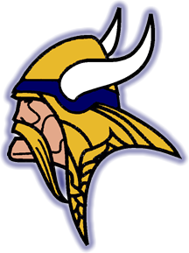

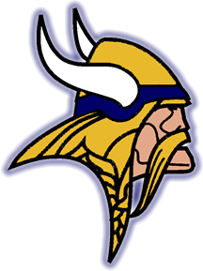

**2021-2022 School Profile**

***2006 Worthington Road***

***Greenville, NC 27858***

***Tel (252) 756-3440 Fax (252) 756-3028***

## Our School

D.H. Conley High School, established in 1970, is one of seven high schools in Pitt County. There are approximately 1635 students attending our school. Our students follow 4 x 4 block schedule and are supported by teachers and staff committed to the success of each student. We value our cooperative relationship with the community and its members. Our school community enjoys the support of local citizens concerned and interested in our success as a school and the success of our students.

## Curriculum

D.H. Conley High School offers a program of comprehensive course work, which must be successfully completed to acquire a high school diploma. Students are registered for classes designed to meet their abilities, individual needs and interests, and career goals. Our school community, along with Pitt Community College, offers dual enrollment for students interested in beginning college coursework while still in high school.

D.H. Conley High School adheres to the North Carolina Future Ready Core course of study. The course levels include *Standard, Honors, and Advanced Placement (AP).* D.H. Conley is pleased to offer the following courses for AP credit on our campus:

Art History Computer Science A. English Literature Psychology

Art Studio Computer Science Prin.. Environmental Statistics

Calculus AB Government/Politics European History U.S. History

Biology English Language Physics World History

*Additional AP courses are provided online through NCVPS and PCVS at the student’s request.*

## College / University Attendance

D.H. Conley class of 2021: 45% of the students plan to attend a four-year college, 47% plan to attend a two-year college, 1% and have joined the Military.

###### **Score Statistics ACT**

D.H. Conley High School ACT No. 341640.

2020-2021 DHC Average Scores: English 17.7; Reading 20.5; Math 20.4; Science 19.7; Composite 19.7

State of NC Average Scores: English 17; Reading 19.2; Math 18.8; Science 18.7; Composite 18.6

**Grading Scale for entering 9th grade in the 2015-2016 school year and thereafter.**

**Letter Grade** **Scale**  **QP** **Honors** **AP**

A 90-100 4.0 5.0 6.0

B 80-89 3.0 4.0 5.0

C 70-79 2.0 3.0 4.0

D 60-69 1.0 2.0 3.0

F <59 0 0 0

FF Failure Due to Absences

**Grading Scale**

**Grading Scale for students entering 9th grade in the 2015-2016 school year and thereafter.**

**Letter Grade** **Scale**  **QP** **Honors** **AP**

A 90-100 4.0 4.5 5.0

B 80-89 3.0 3.5 4.0

C 70-79 2.0 2.5 3.0

D 60-69 1.0 1.5 2.0

F <59 0 0 0

FF Failure Due to Absences

###### **Athletics**

**Fall Sports**: Varsity and JV football, Cross Country, Varsity and JV volleyball, Women’s Tennis, Varsity and JV Men’s Soccer, Varsity and JV cheerleading, Women’s Golf

**Winter Sports:** Varsity and JV Men’s Basketball, Varsity and JV Women’s Basketball, Wrestling, Varsity and JV Cheerleading, and Swimming

**Spring Sports:** Varsity, JV baseball and 9th grade Baseball, Varsity and JV Softball, Track, Men’s Tennis, Men’s Golf, JV and Varsity Women’s Soccer

***Extracurricular Opportunities***

Beta Club, Bible Club, BRAKES Club, Book Wars, Chess Club, Choices Club, Close Up Club, Dance Honor Society, DECA Club, Elevate Club, Envirothon Club, FTA Club, FBLA Club, HEAL Club, HOSA Club, JROTC Club, Lacrosse Club, Mu Alpha Theta Society, National Art Honor Society, National Honor Society, National French Honor Society, National Technical Honor Society, NC- FCCLA Club, NEHS, Robotics Club, Roots and Shoots Club, SASA Club, SCA Club, Science National Honor Society, Science Olympiad, Skills USA Club, Sociedad Honoraria Hispanica, Quiz Bowl, Theater Arts Honor Society, Writing Club

**Page 3**